PPenn Kraft 052.6

Fragment of a single layer of papyrus 5.5 x 8.0 cm in dimension. Has been recently against the grain of the verso. Recto is covered with a very thin layer of sandy-brown plaster. Small traces of a dark amber glue or adhesive of some sort is visible at places on the verso.
Two long black strokes at first resembled letters. One was covered with a small section of folded-down papyrus. This was gently removed without treatment, and revealed nothing of interest beneath. Closer examination of the second black stroke suggests it may not be writing but rather compressed glue or other detritus compounded into the surface of the papyrus.
The plaster (similar to what others observed as a “peanut-brittle” type substance) on the recto does not easily separate from the papyrus, and where it does no writing is revealed. I use a toothbrush to abrade the plaster substance and then small kitchen knife to pry up some of the plaster that has cracked. This combination works well to expose the papyrus beneath the “peanut-brittle” but does not reveal any further traces of writing underneath. After removal of the “peanut-brittle,” the papyrus starts to deteriorate and breaks into several fragments.
This appears in all likelihood to be a blank piece of cartonnage.

Verso, before any investigation:
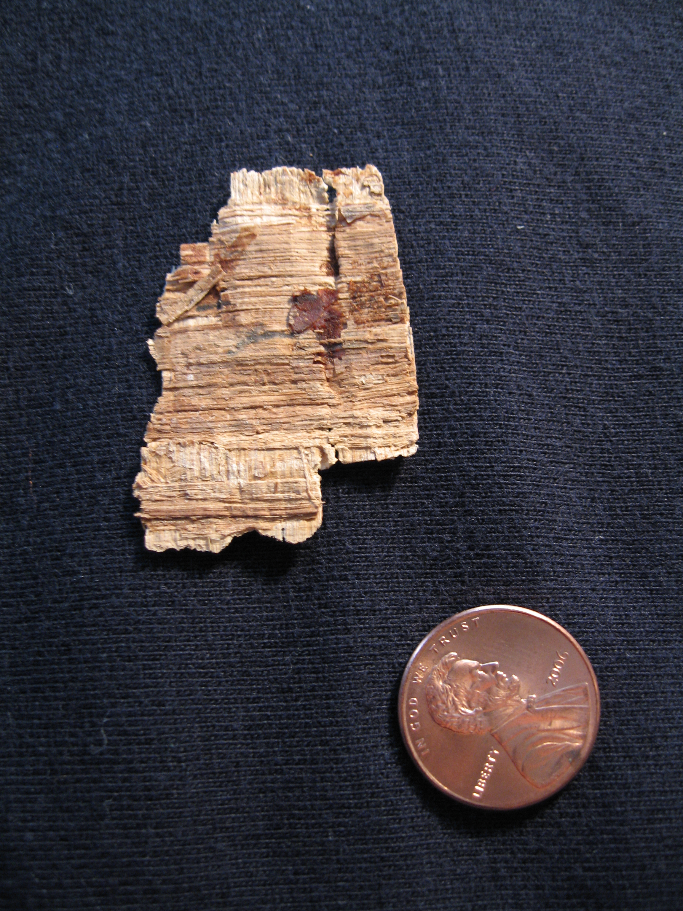

Verso, small piece of folded-over papyrus has been removed.
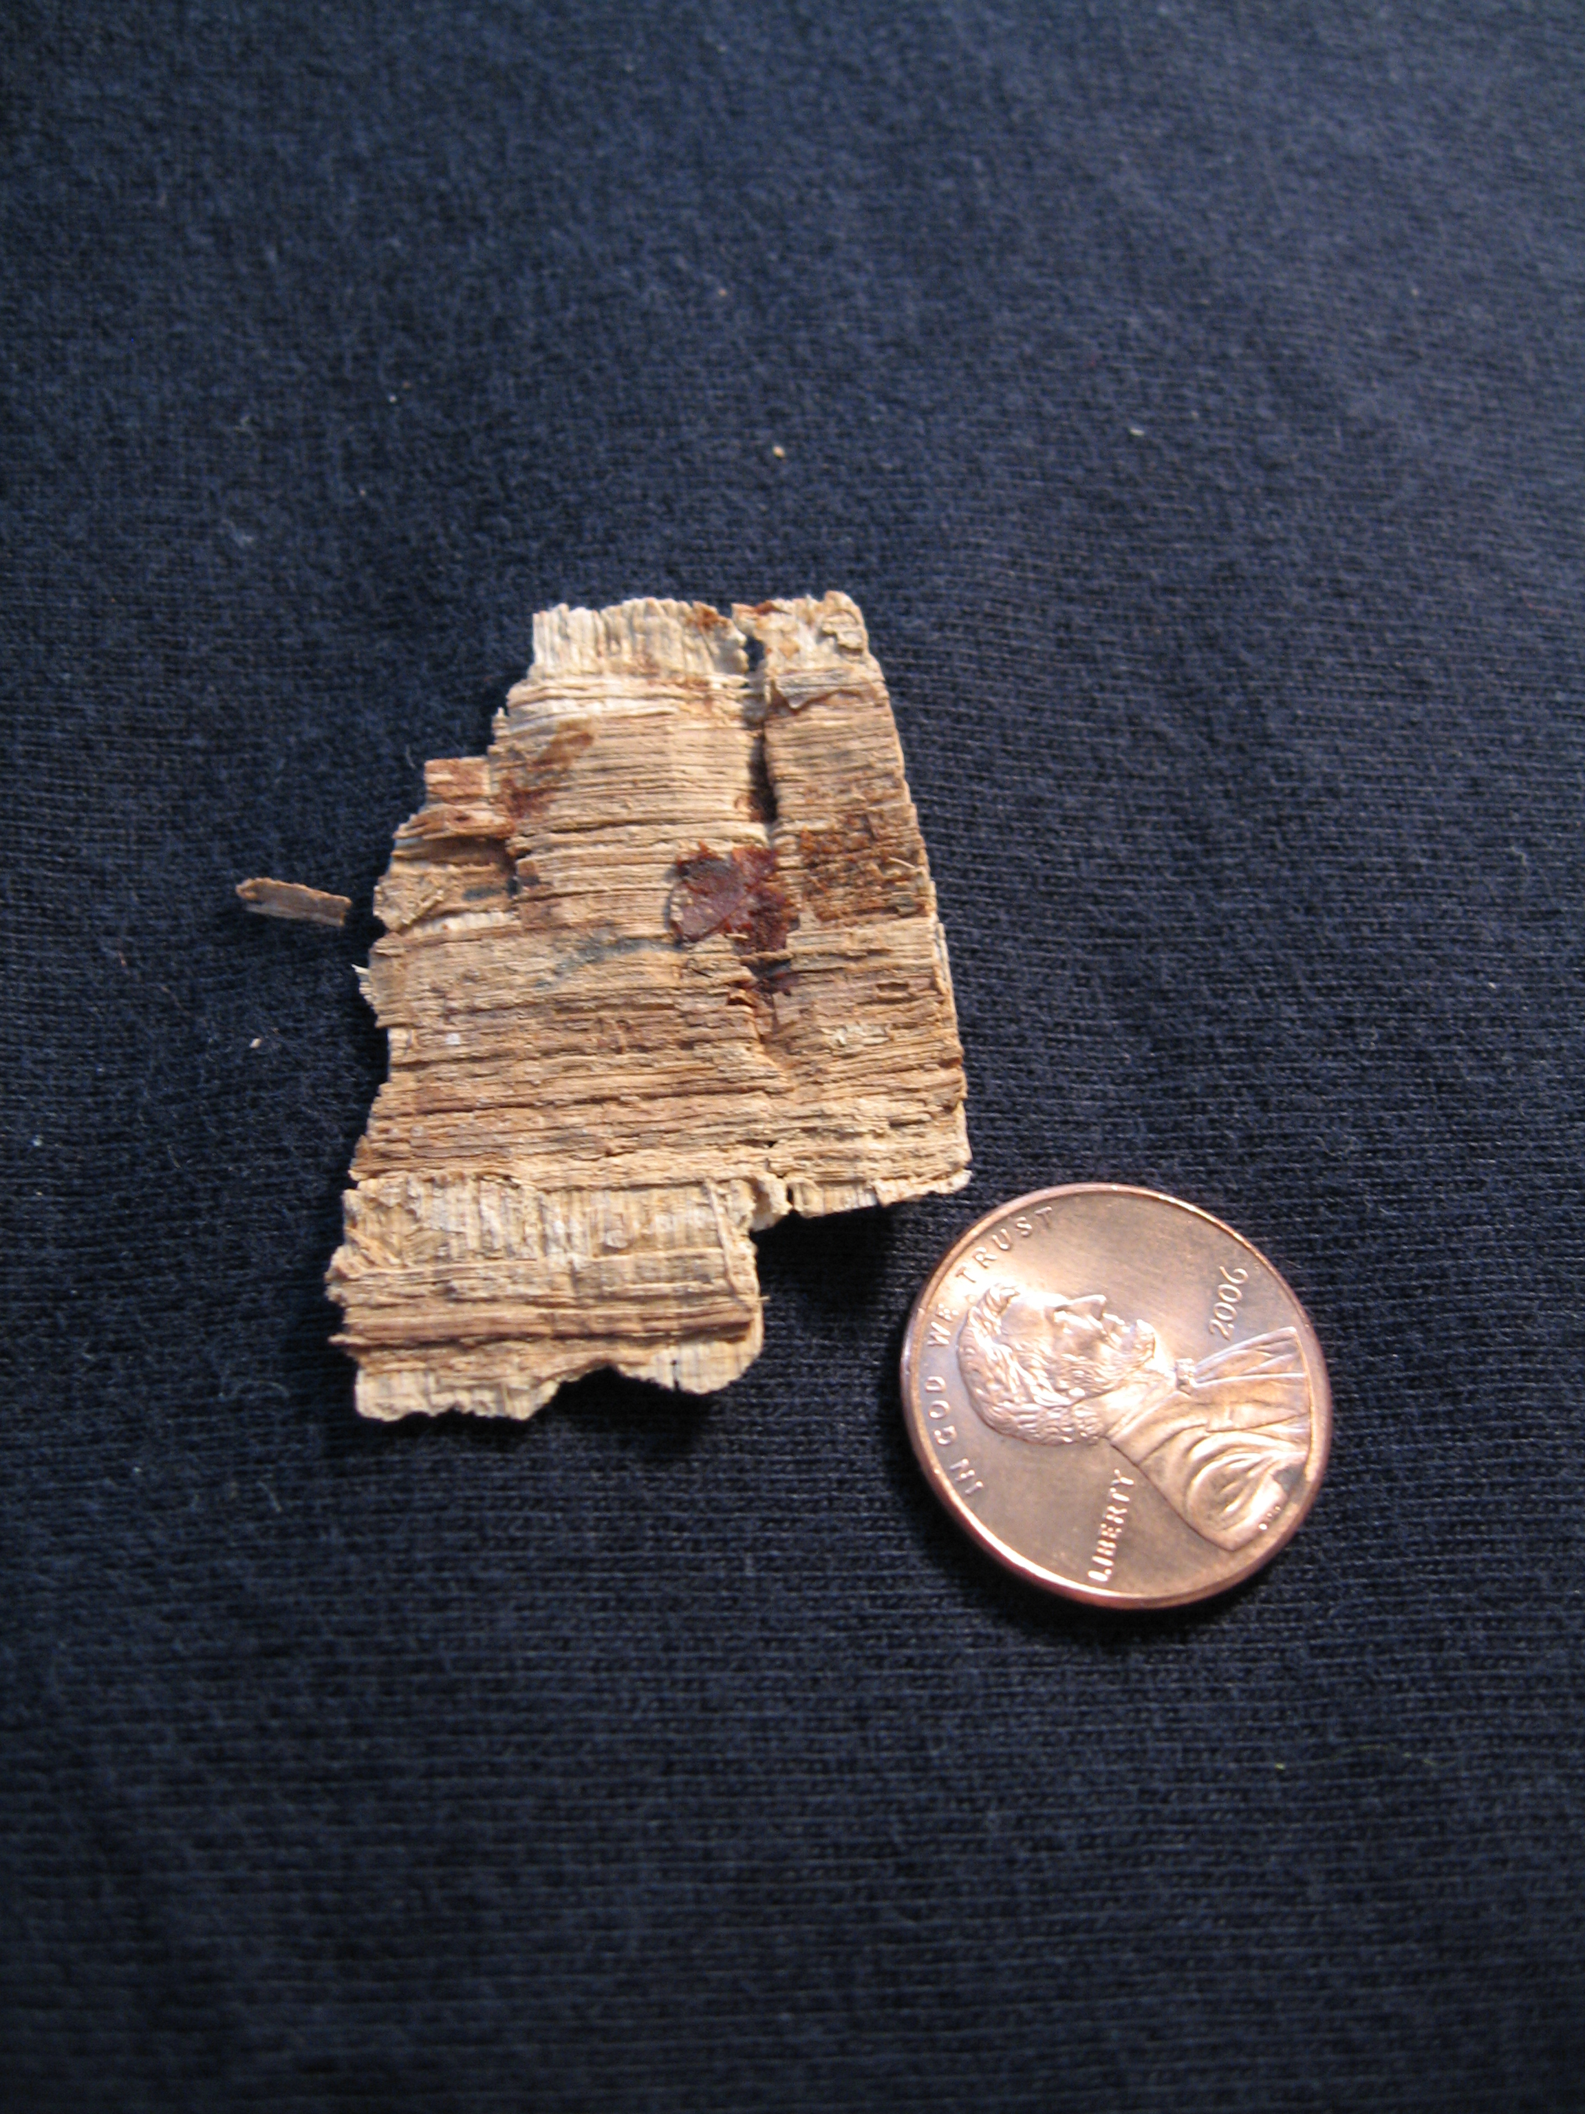

The plaster or “peanut-brittle” substance
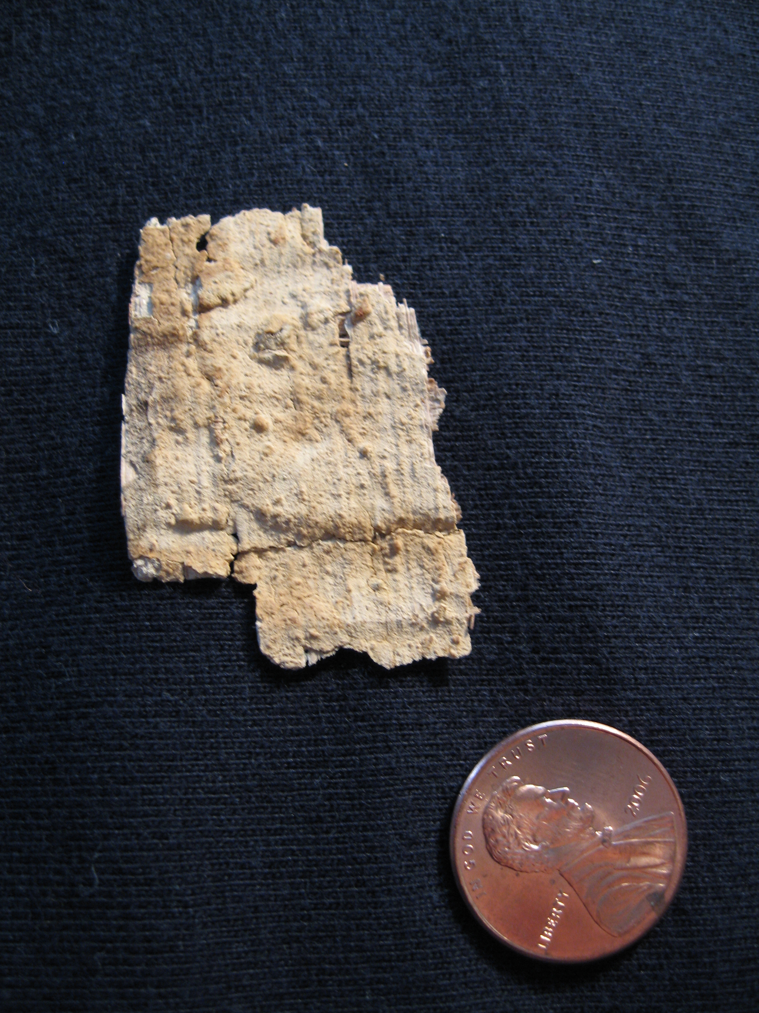

Investigating the substance with a small kitchen-knife, some loose parts flake away.
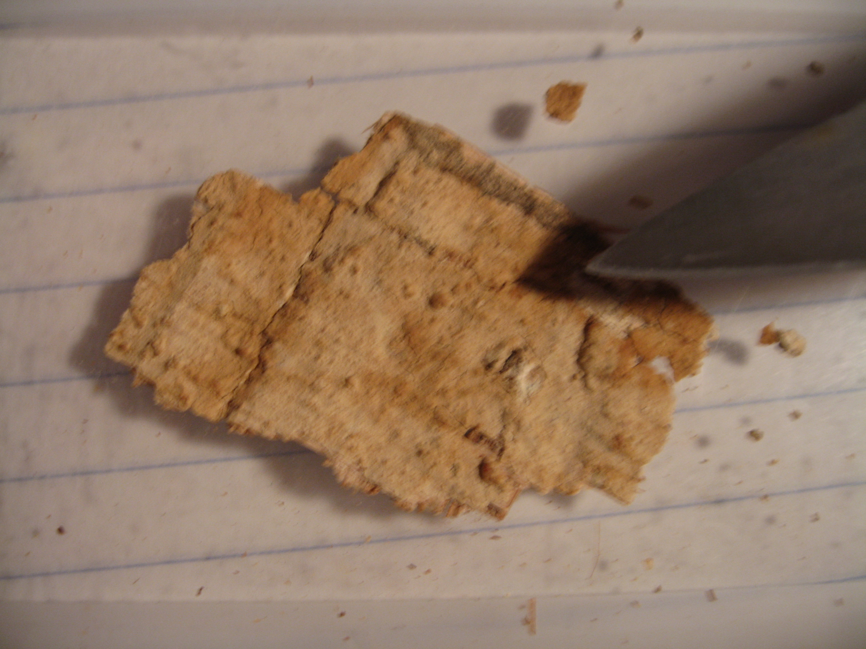
Scrubbing lightly with a toothbrush loosens the plaster substance, and more may be removed with the knife.
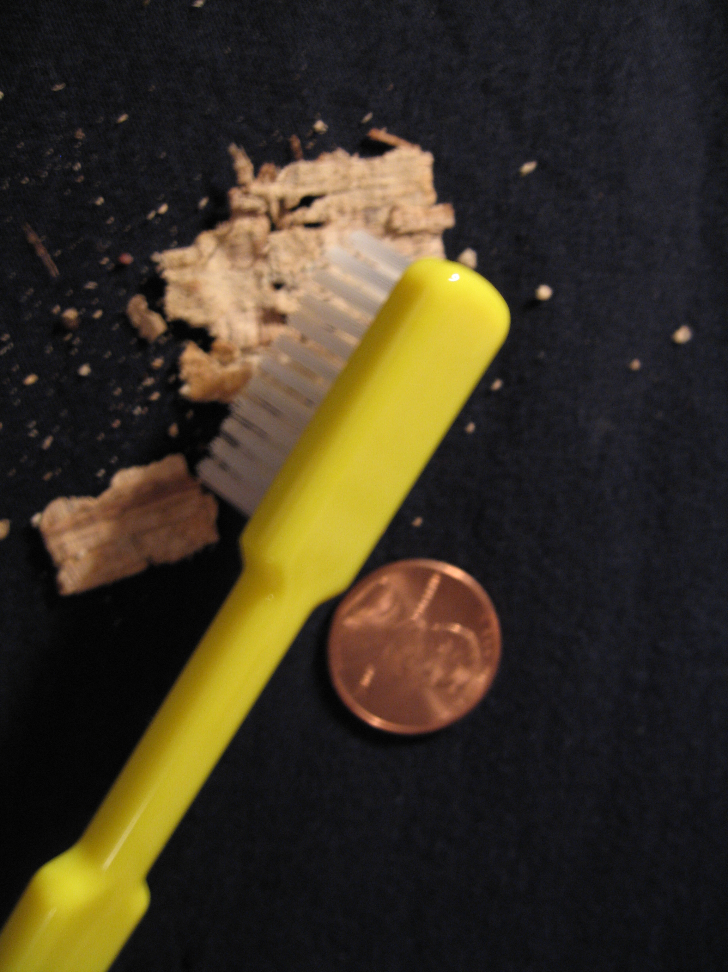

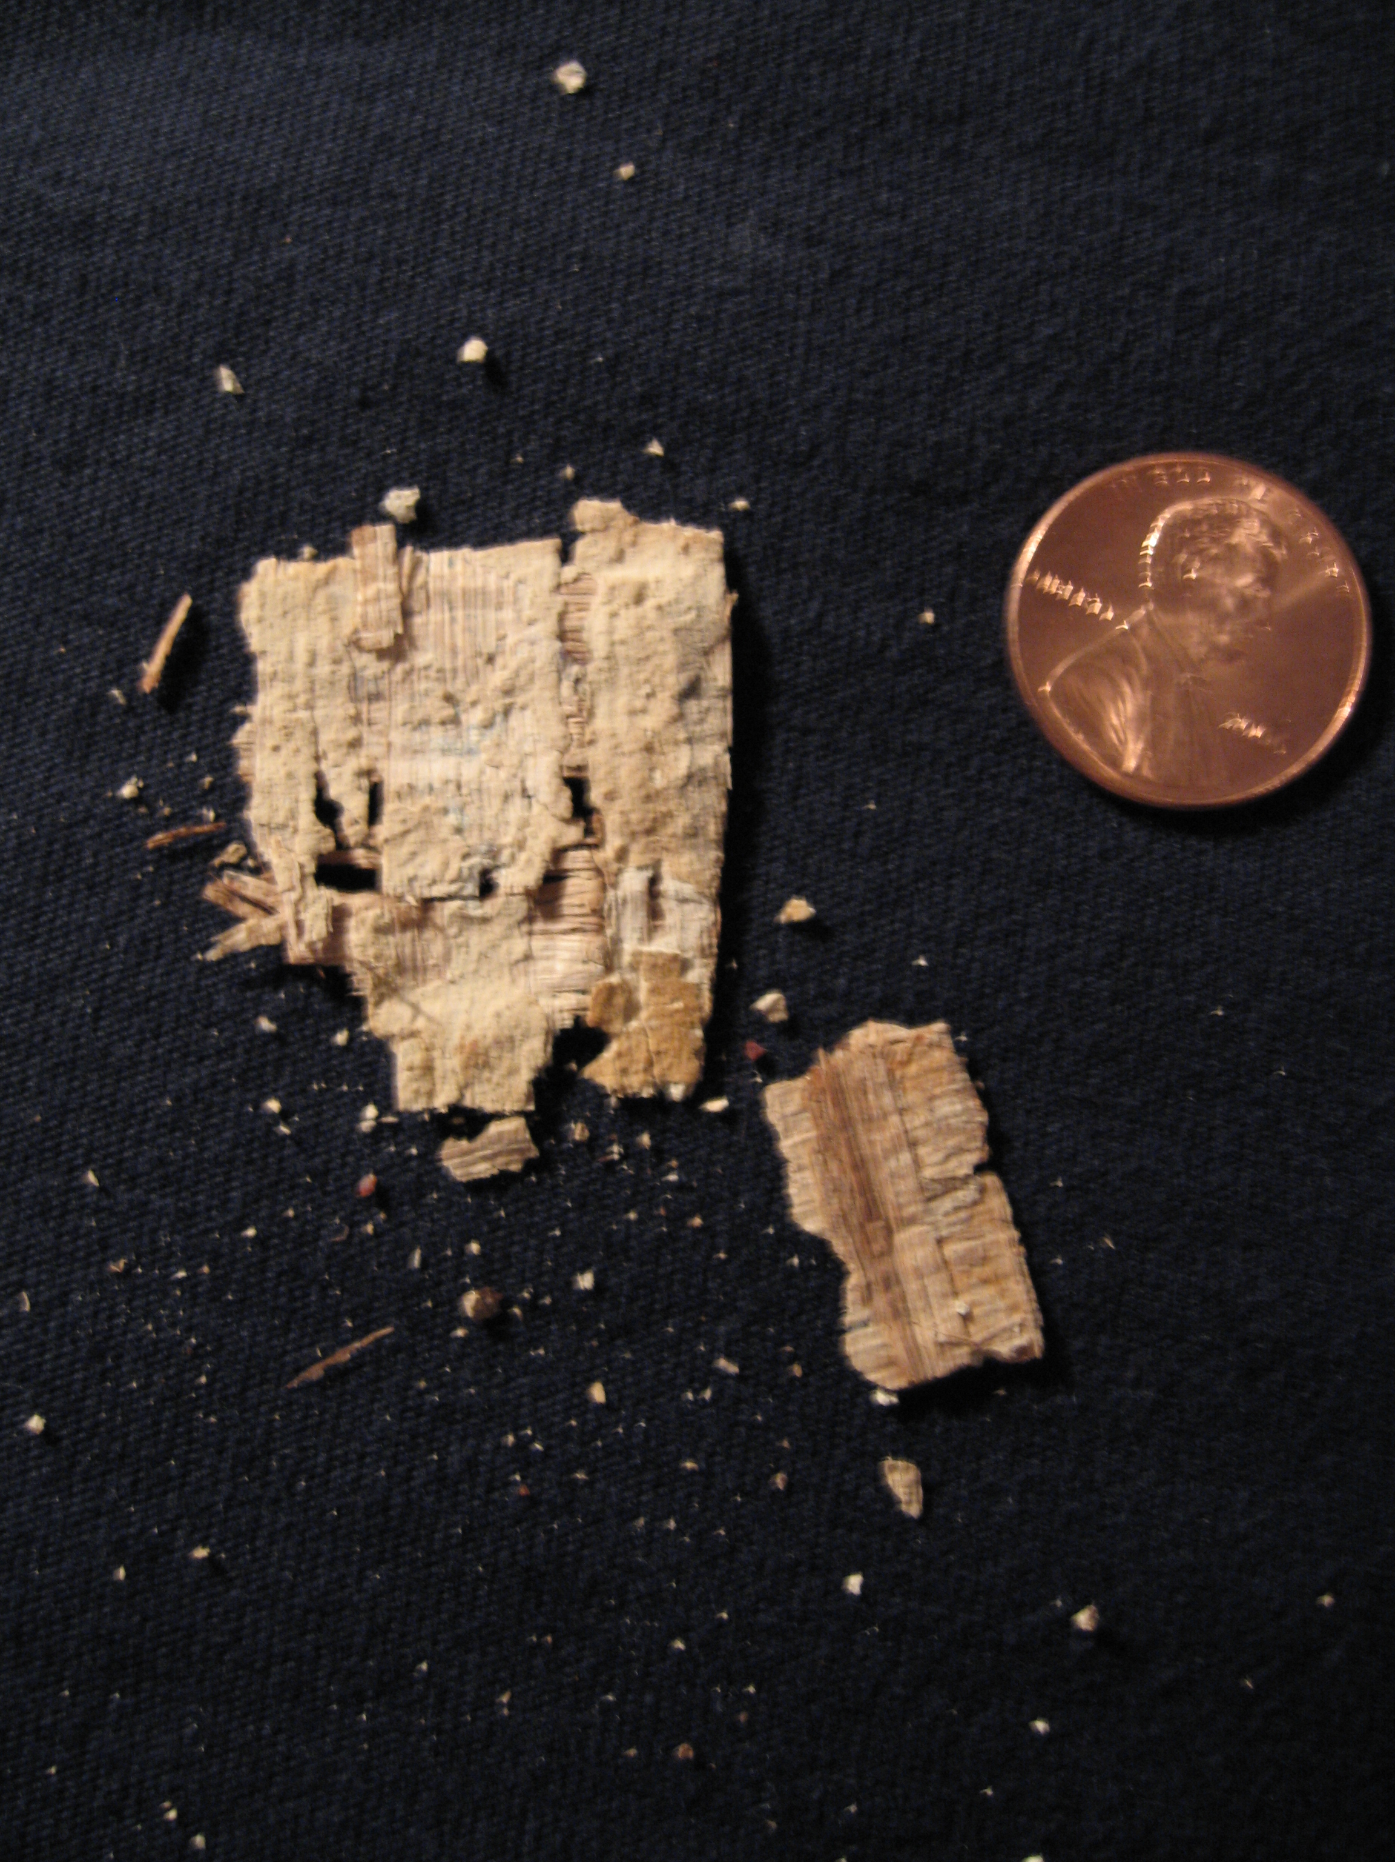
Finally, the recto with most of the plaster removed reveals a blank surface.

