Christina Gieske
CLST 735
Separation of papyrus

Fragment 052.5

Dimensions: approximately 3.5 x 2.5 cm

Description:

At least two layers are visible with some sort of shiny adhesive holding the two layers together. There are perhaps more layers visible, but split layers are another possibility. The fragment contains no obvious ink or writing. The piece has minimal other distinctive markings – no burn marks, plaster, paint, etc.

Front of fragment:
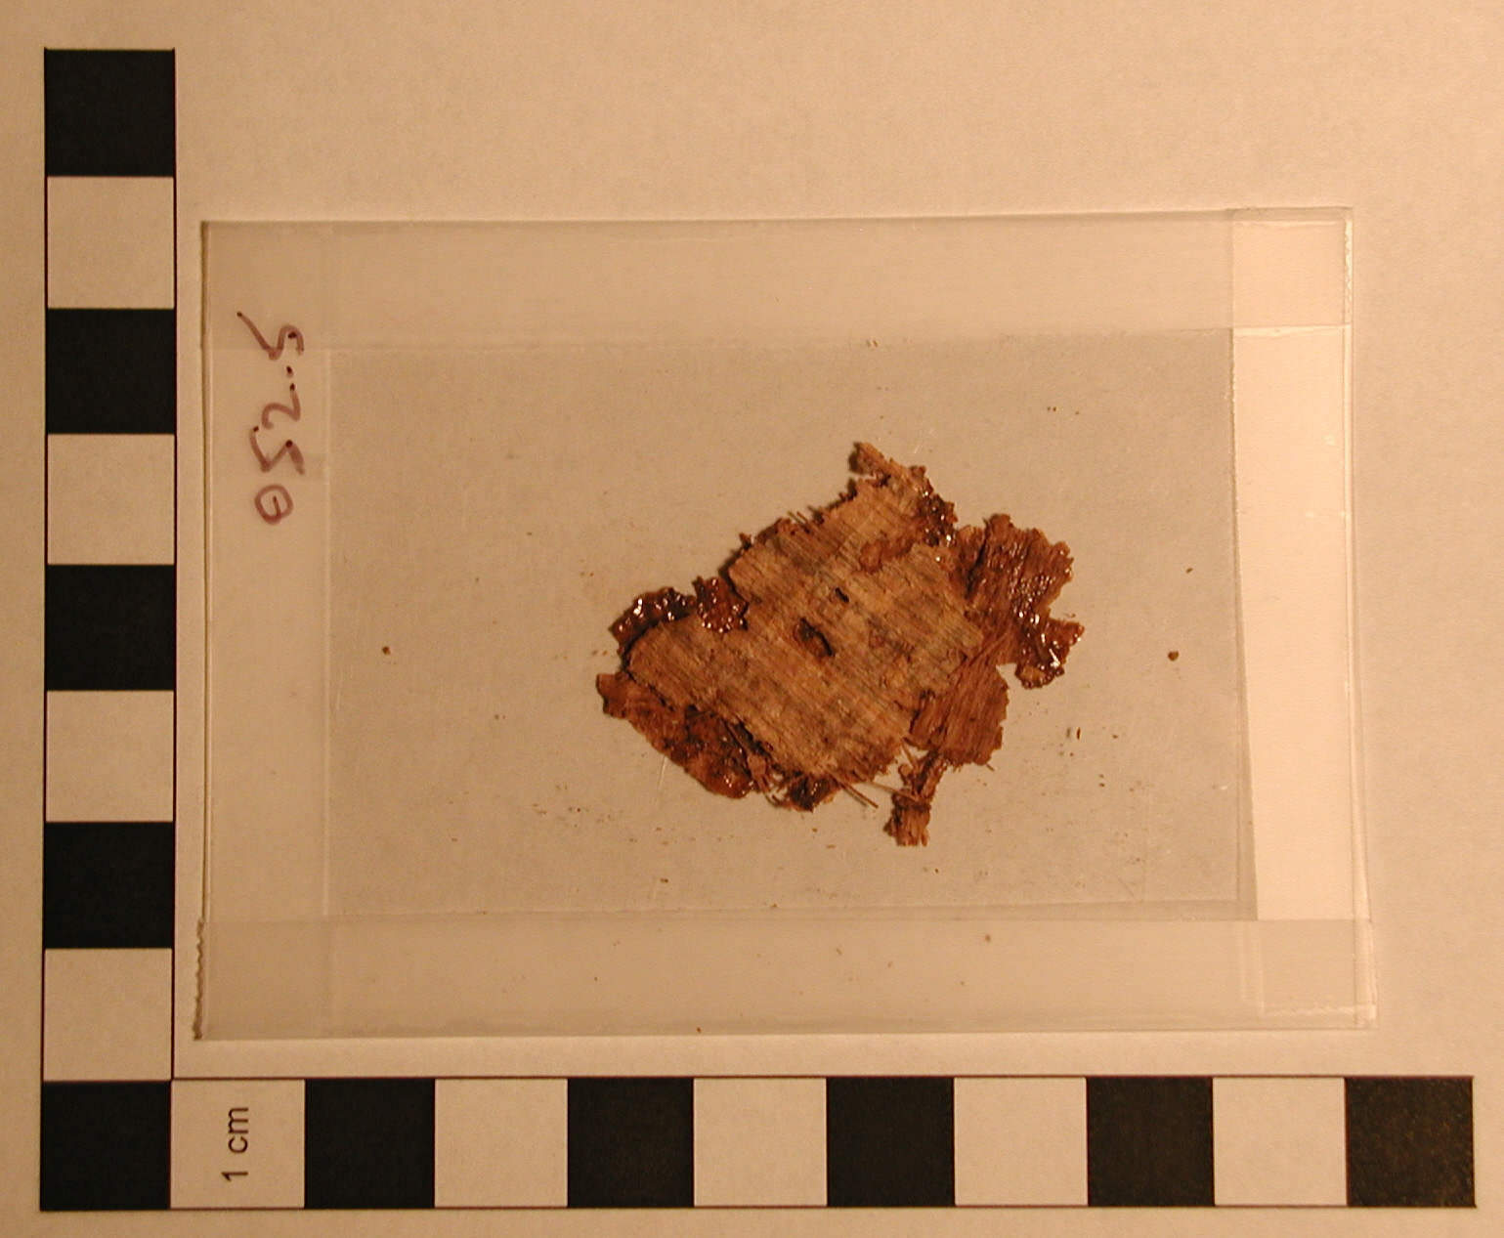

Back of Fragment:
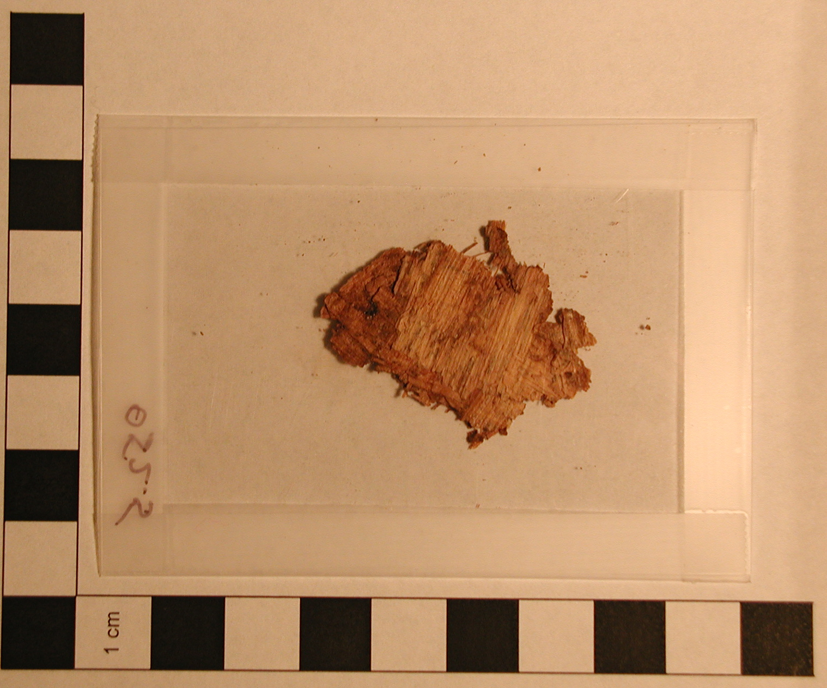

Procedure:

First, I tried using a steam bath for about 20 minutes to separate the layers. Although the steam softened the papyrus and made the visible edges of the layers flexible, I was unable to separate the layers due to the glossy adhesive which did not loosen in the steam.

After discussing my fragment with a classmate, Amanda Reiterman, I decided to try alcohol on the adhesive. She separated a fragment with a glossy adhesive and was able to dissolve the adhesive by gently swabbing it with alcohol (rubbing alcohol, 50% by volume). My attempt with the alcohol proved unsuccessful. The rubbing alcohol did not dissolve the adhesive in any way. In the process of trying to get the swab with the alcohol to the spot of adhesion, a small piece of my fragment tore off. The glossy adhesive remained visible, even with ridges, on both pieces, even after another alcohol rub.

Front of fragment after attempt to dissolve adhesive with alcohol:
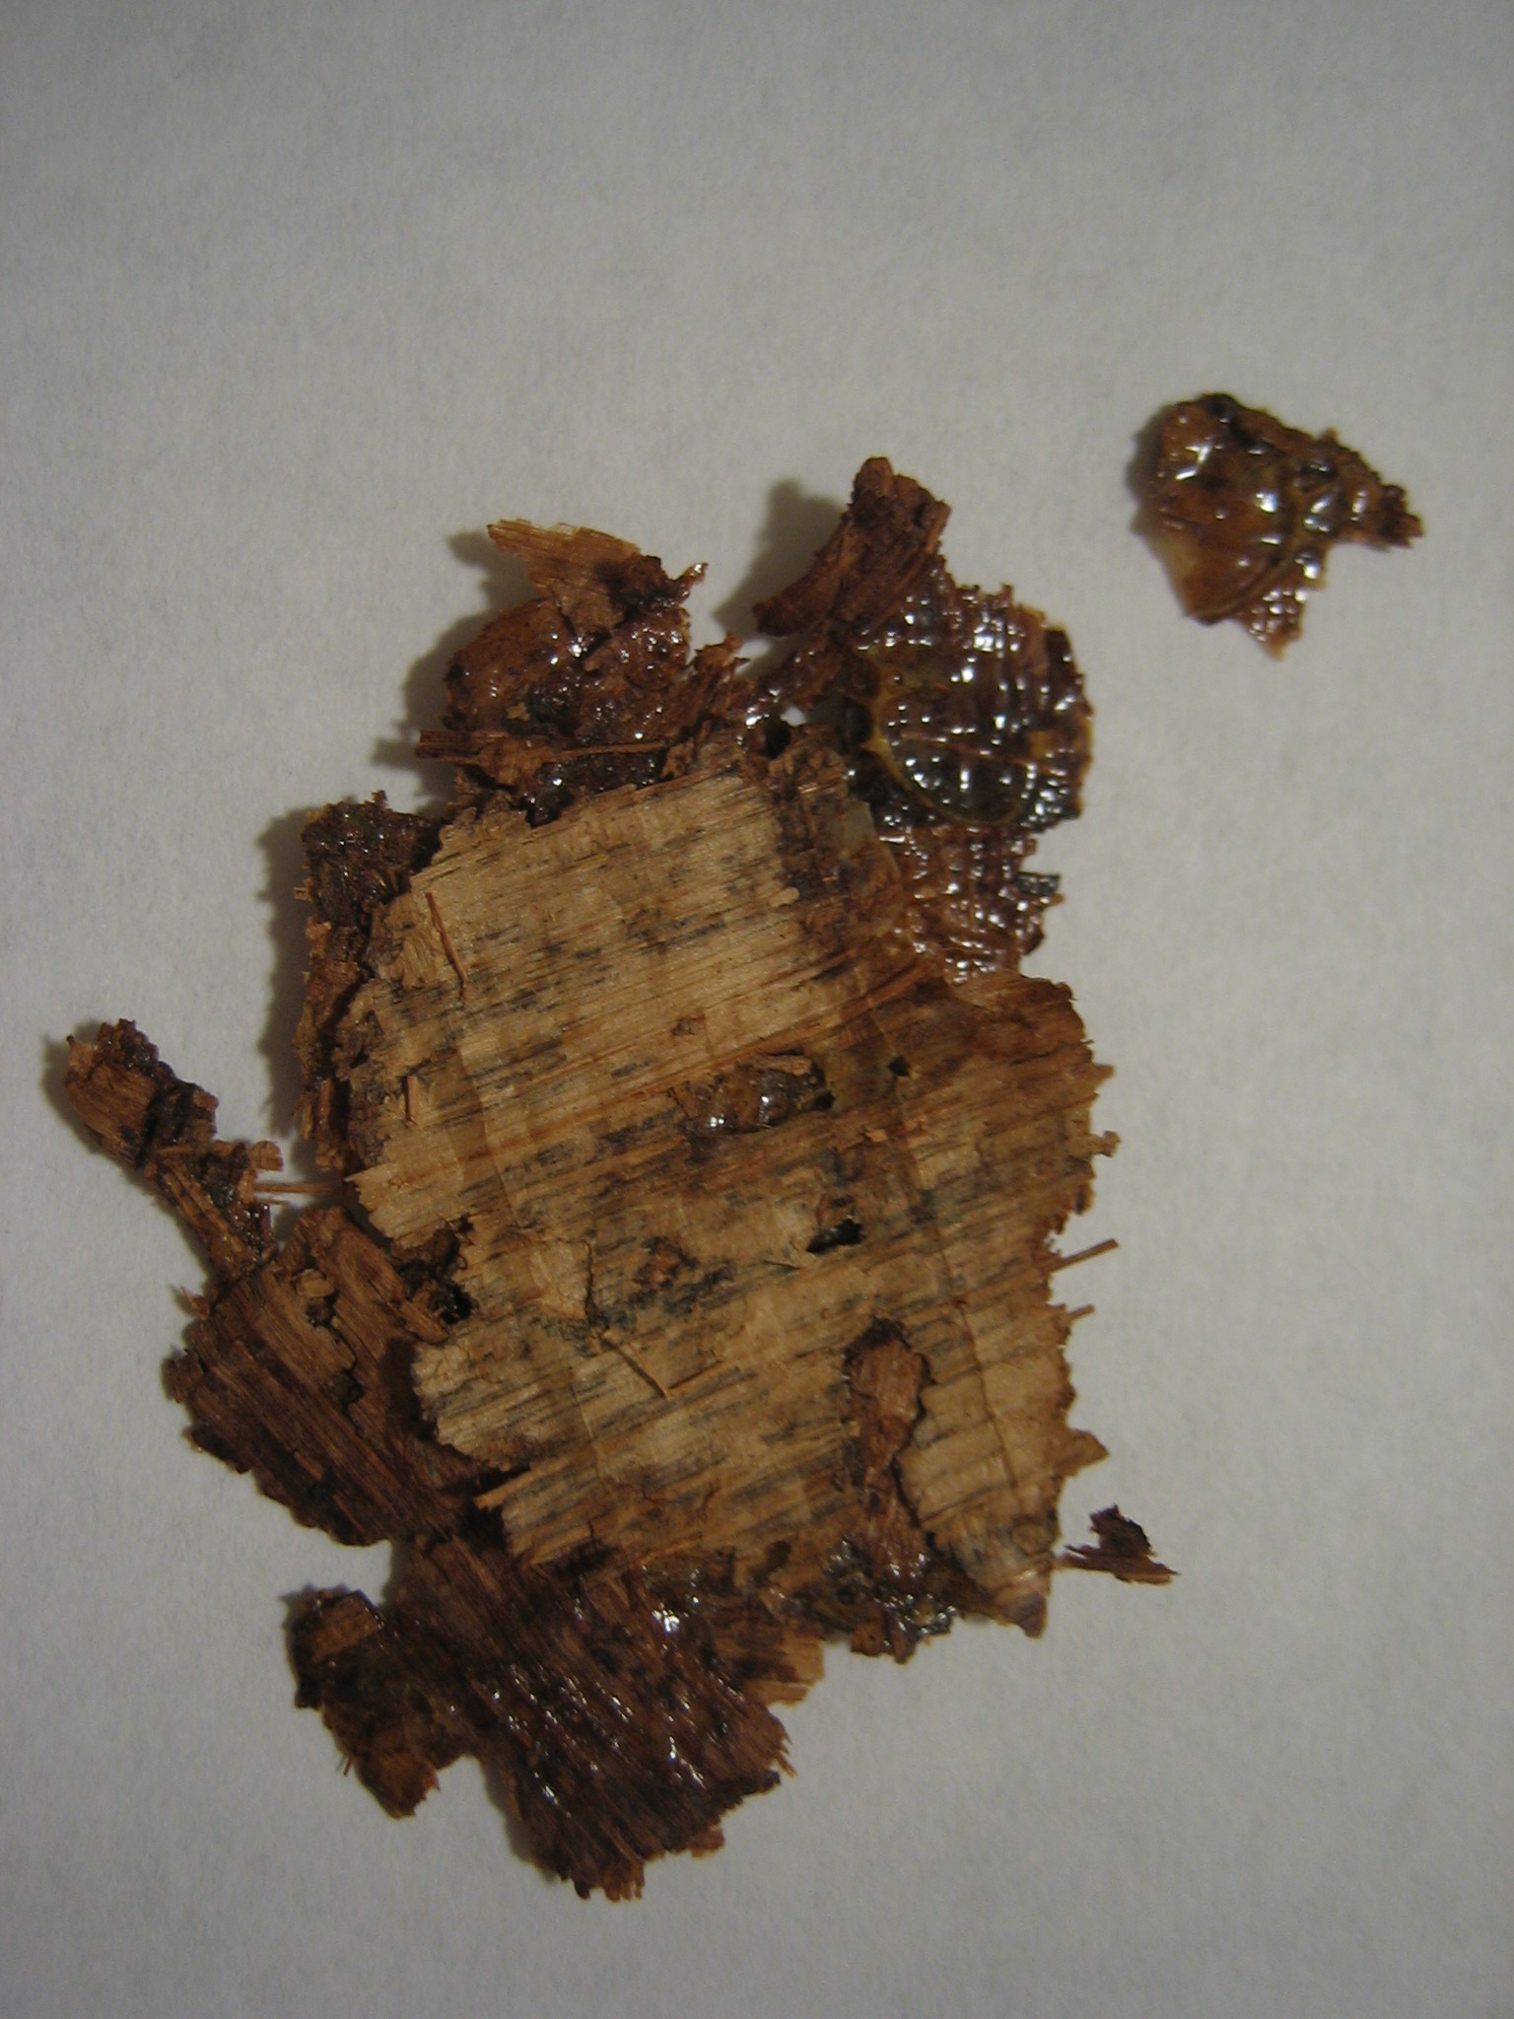

Since the alcohol was ineffective on the glossy adhesive, I decided to try acetone as a solvent for it. I acquired 100% acetone from a chemistry lab and tried gently swabbing the visible adhesive with the acetone. The acetone made no visible difference on the adhesive ridges, and I could not get the swab in between the layers. Another piece of the fragment fell off during attempts to use the acetone as a solvent.

Fragment after acetone treatment (Note that adhesive ridges are still visible even after swabbing with acetone):
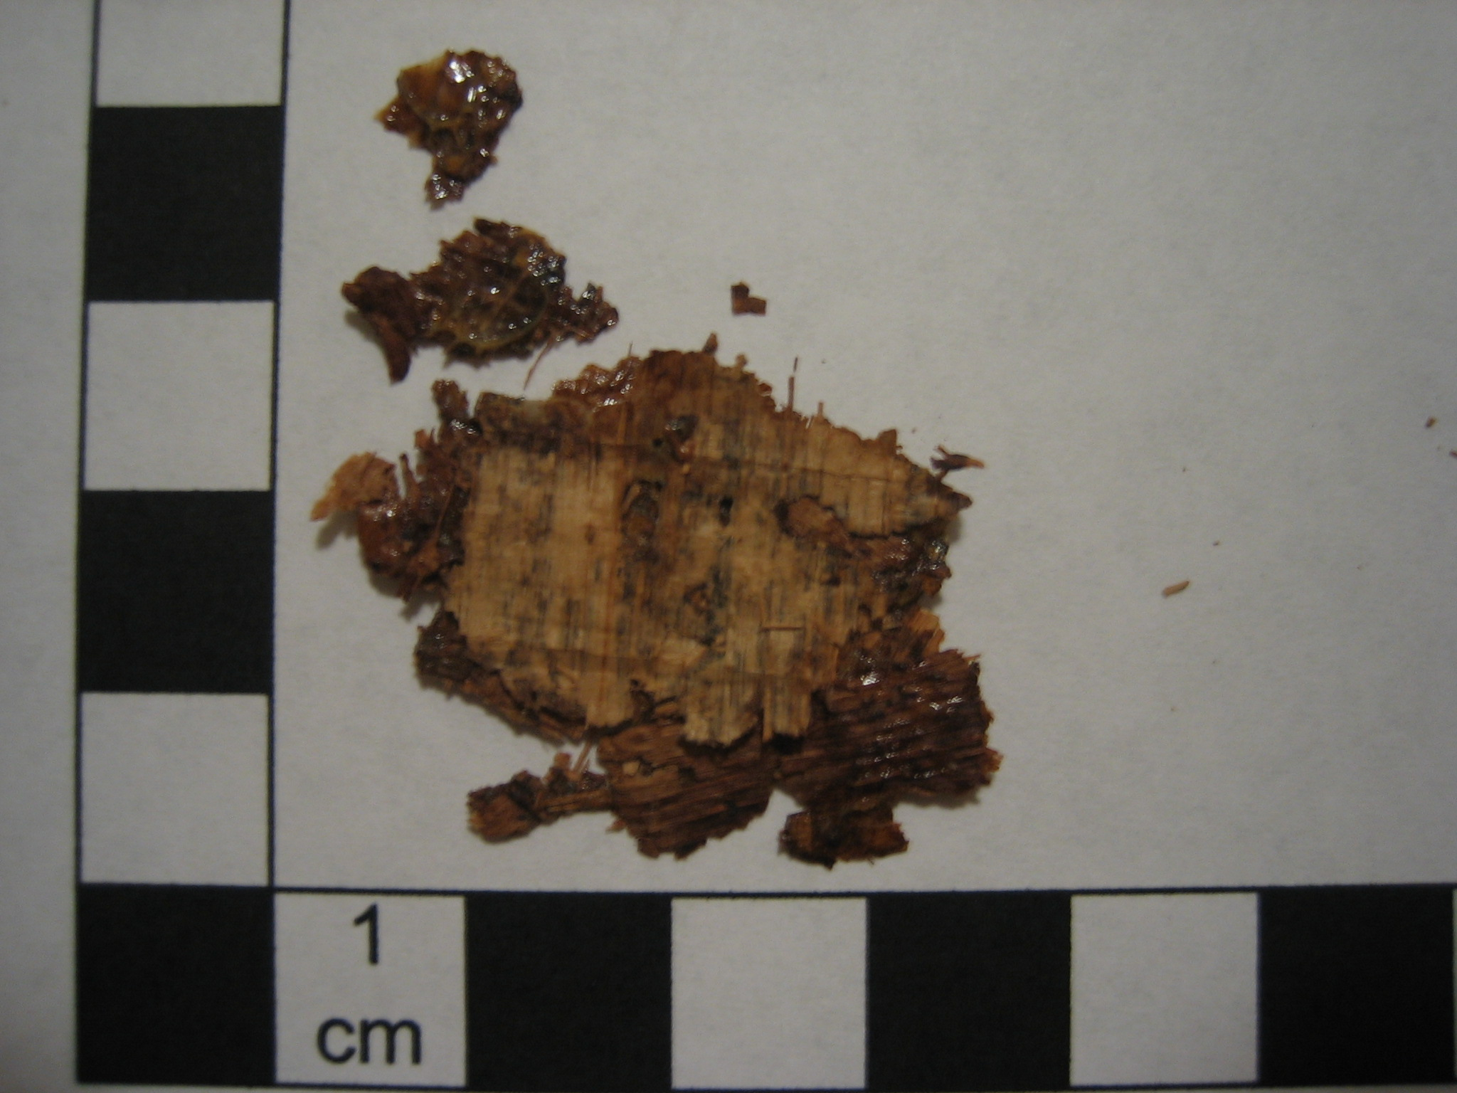

Since acetone is one of the best general solvents, its ineffectiveness was rather distressing. The chemist, from whom I obtained the 100% acetone, did mention another stronger solvent, methyl chloride, which she was willing to obtain for me. However, the ineffectiveness of both alcohol and acetone, one which worked as a solvent for a classmate and the other which should have dissolved the adhesive, made me wonder if perhaps the problem was in the method of using the solvent rather than the choice of solvent itself. Perhaps applying the solvent with a cotton swab was the problem. After discussing the problem with the chemist who supplied the acetone, she suggested trying humidification for a longer period of time since the original steam bath softened the edges. The papyrus fragment was place in a steam bath and humidified overnight. The result of this treatment was essentially the same as the original steam bath. No pictures were taken due to the lack of change. More drastic measures seemed to be required. The next procedure I attempted was to soak the entire fragment in alcohol, minus the two small pieces that had broken off during previous treatments. Again, the fragment was left soaking overnight. This particular treatment discolored the fragment somewhat and caused the edges to curl. Additionally, the papyrus became very delicate and was difficult to handle without damaging it. In particular, the fibers became very pliable and came away individually rather than as part of a layer.

Front of fragment after overnight soak in alcohol:
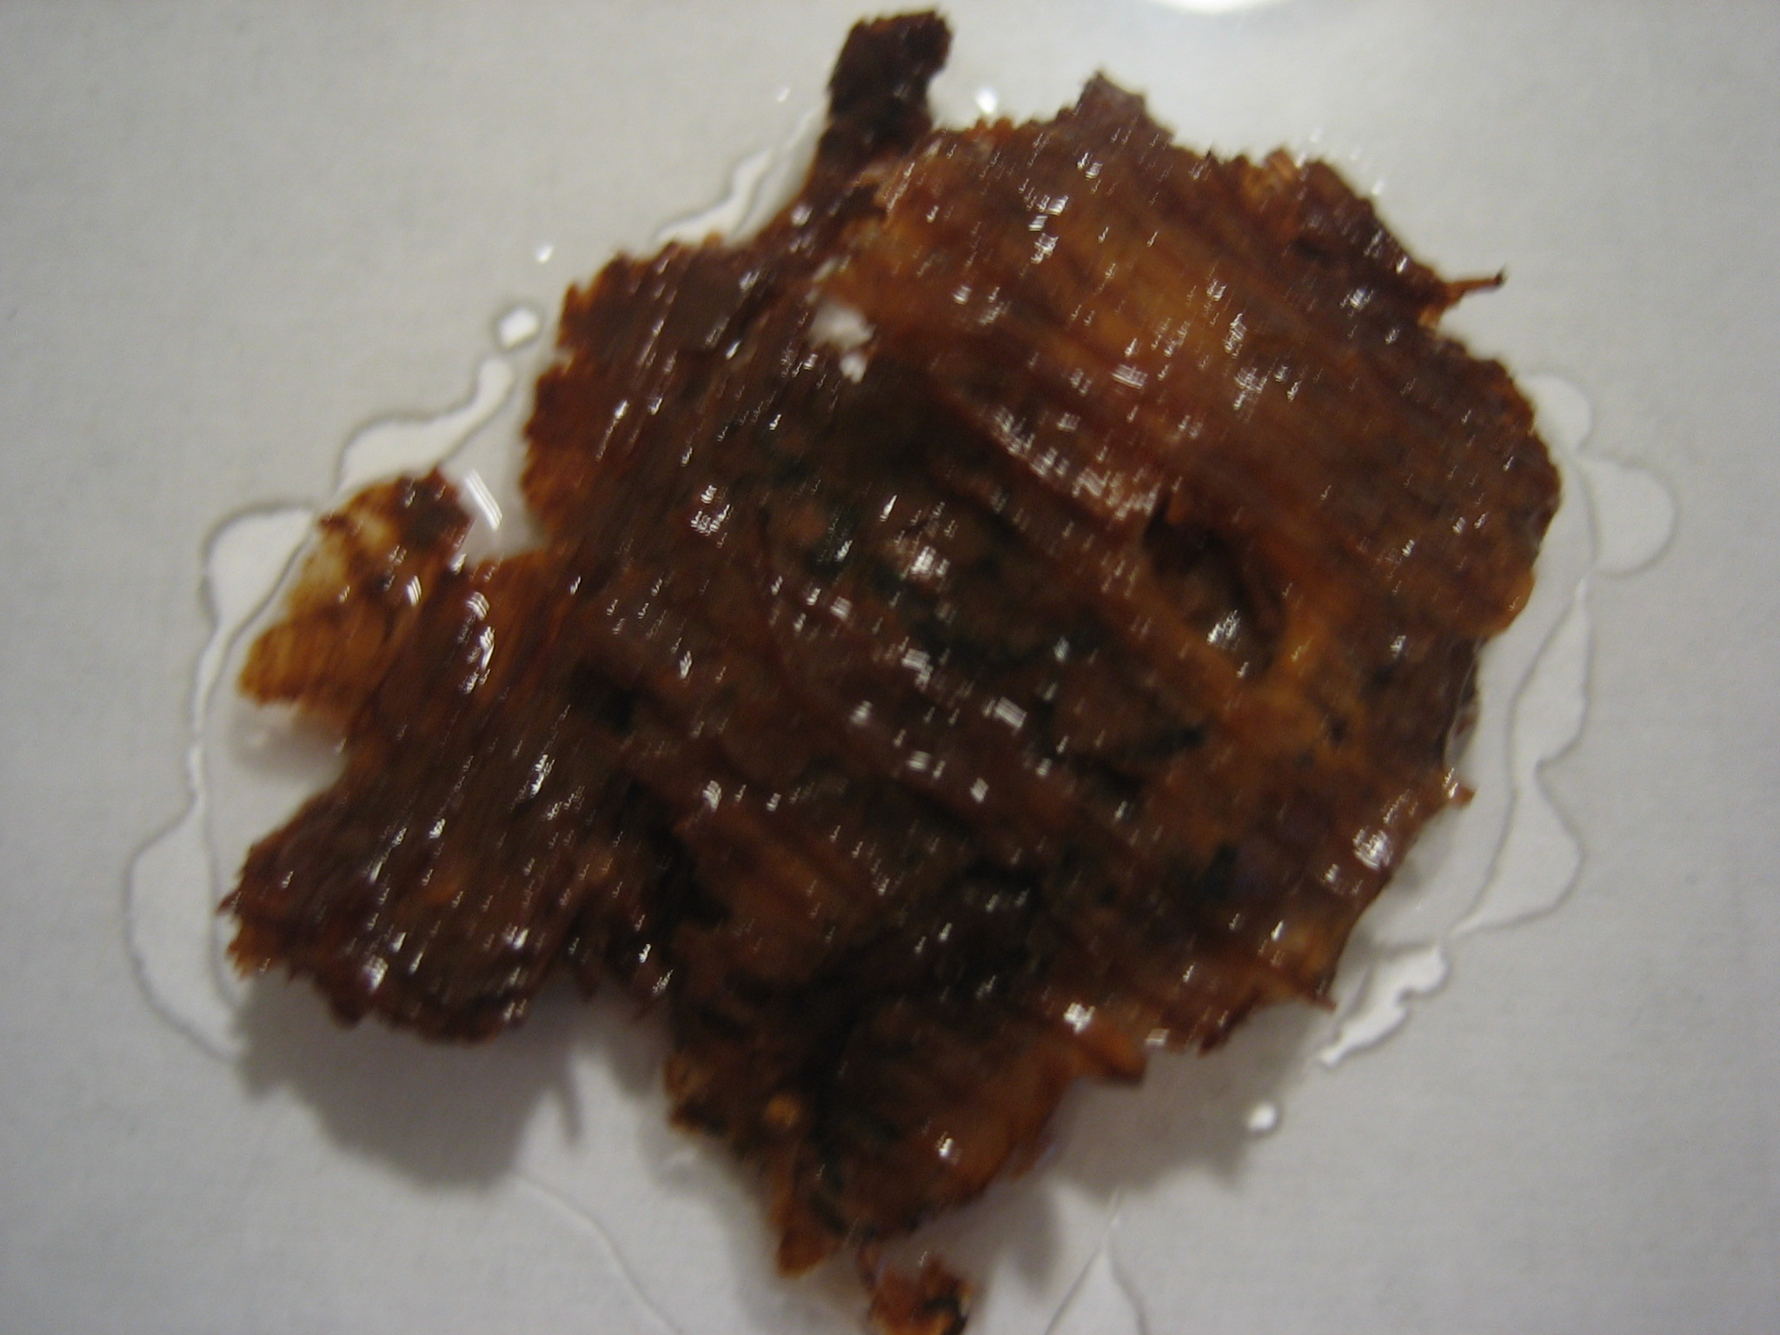

Back of fragment after overnight soak in alcohol:
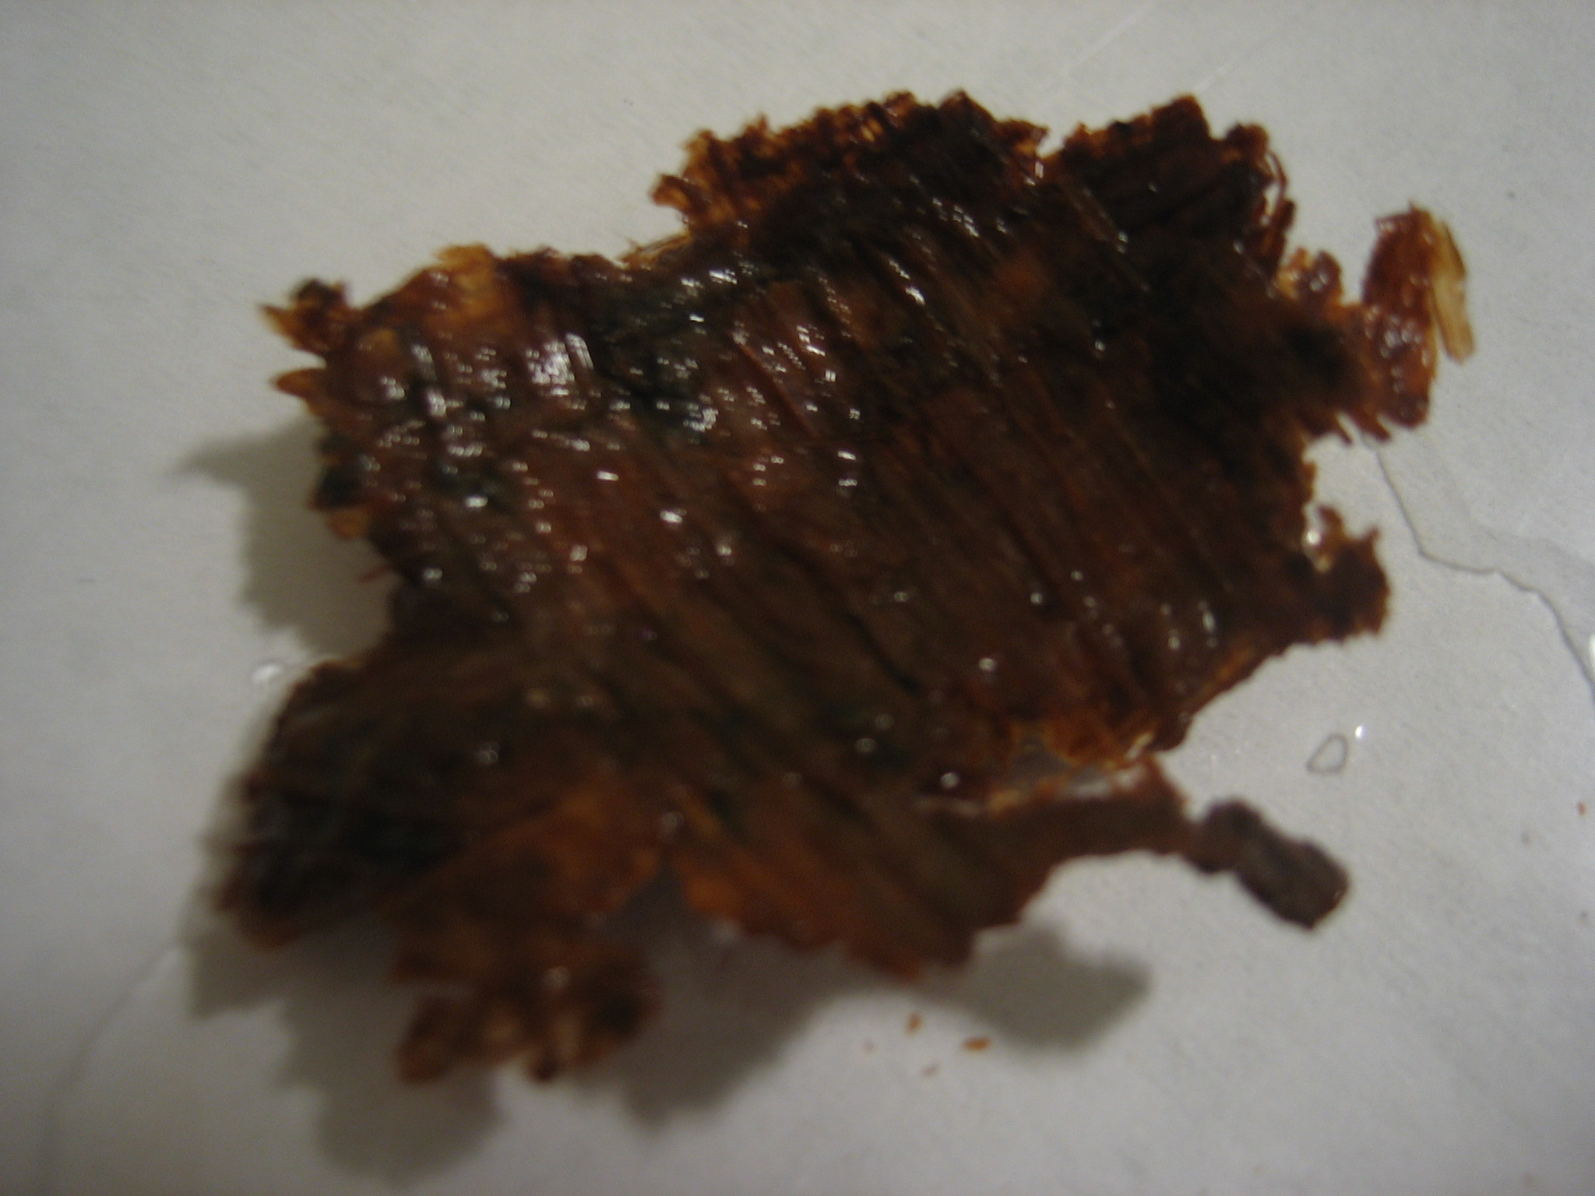

Side view of fragment after alcohol soak:
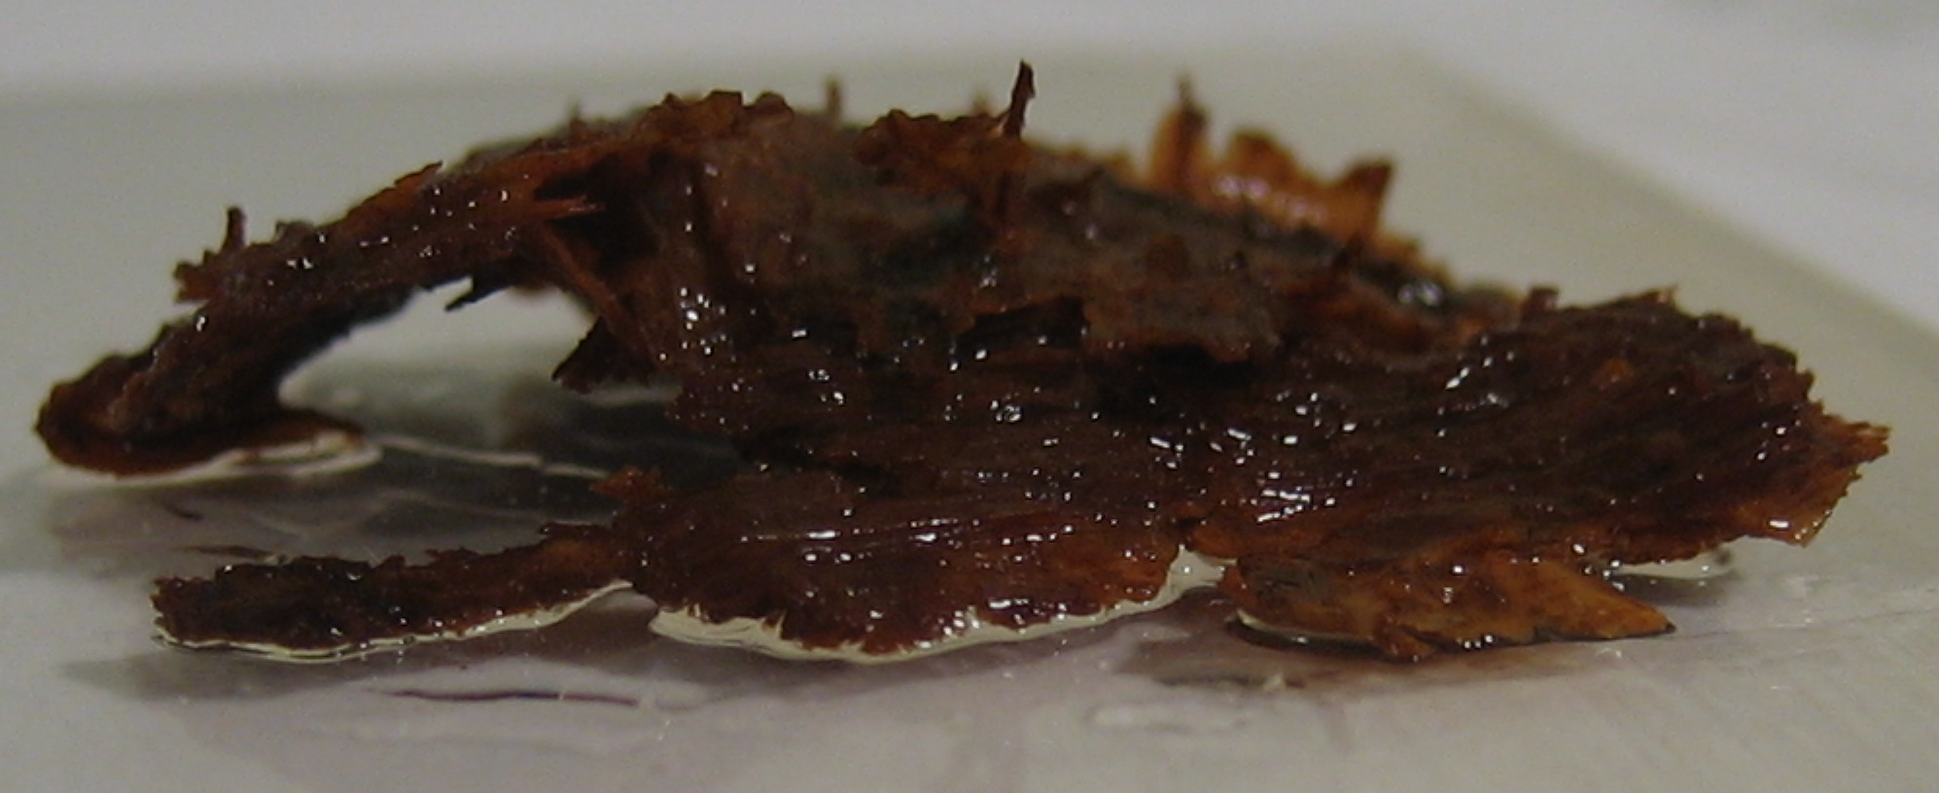

As the side view shows, edges of the layers did separate. I attempted to separate what I could, working gently with a pair of tweezers and a dull flat-bladed knife. Due to the extreme delicacy of the papyrus, this effort was minimally successful. Additionally, the alcohol soak did not affect the adhesive on the fragment. I did manage to expose new surface on the back of the papyrus, but I was unable to remove the layer covering it intact. Instead, the fibers pulled away individually, and I was left with numerous bits and pieces of that layer.

View of the newly exposed surface:
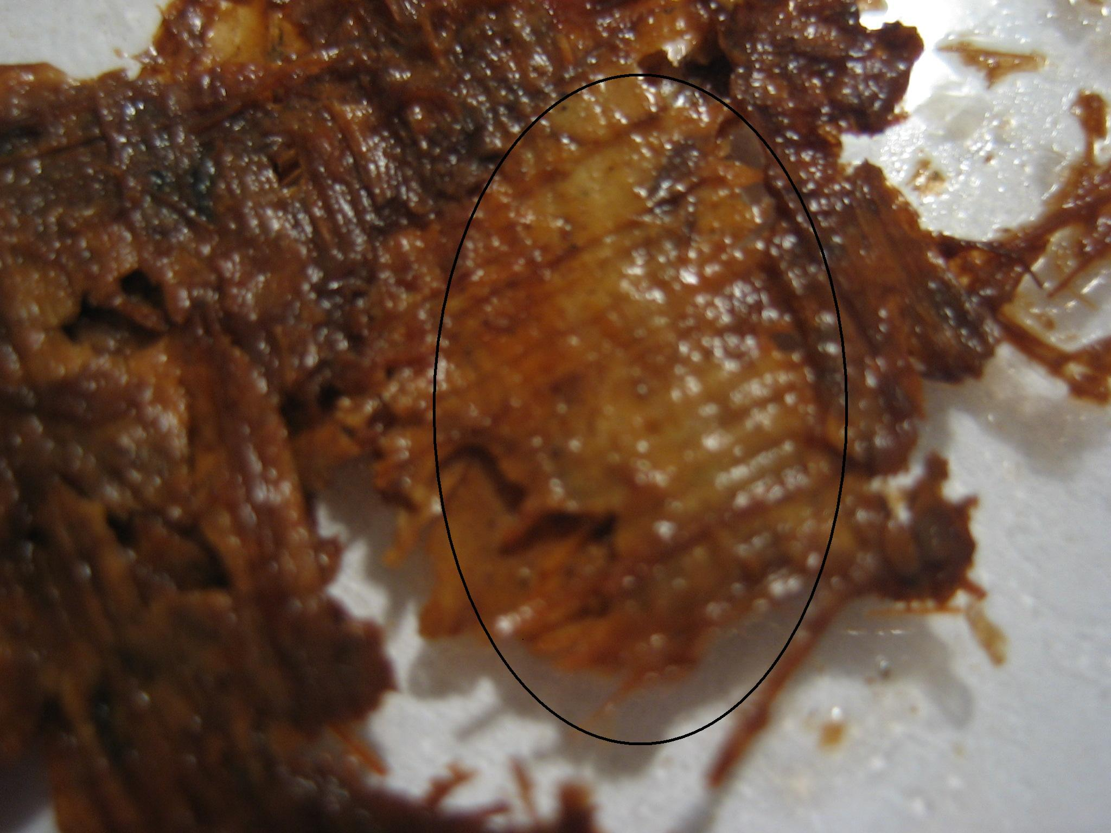

Resulting damage from attempted separation:
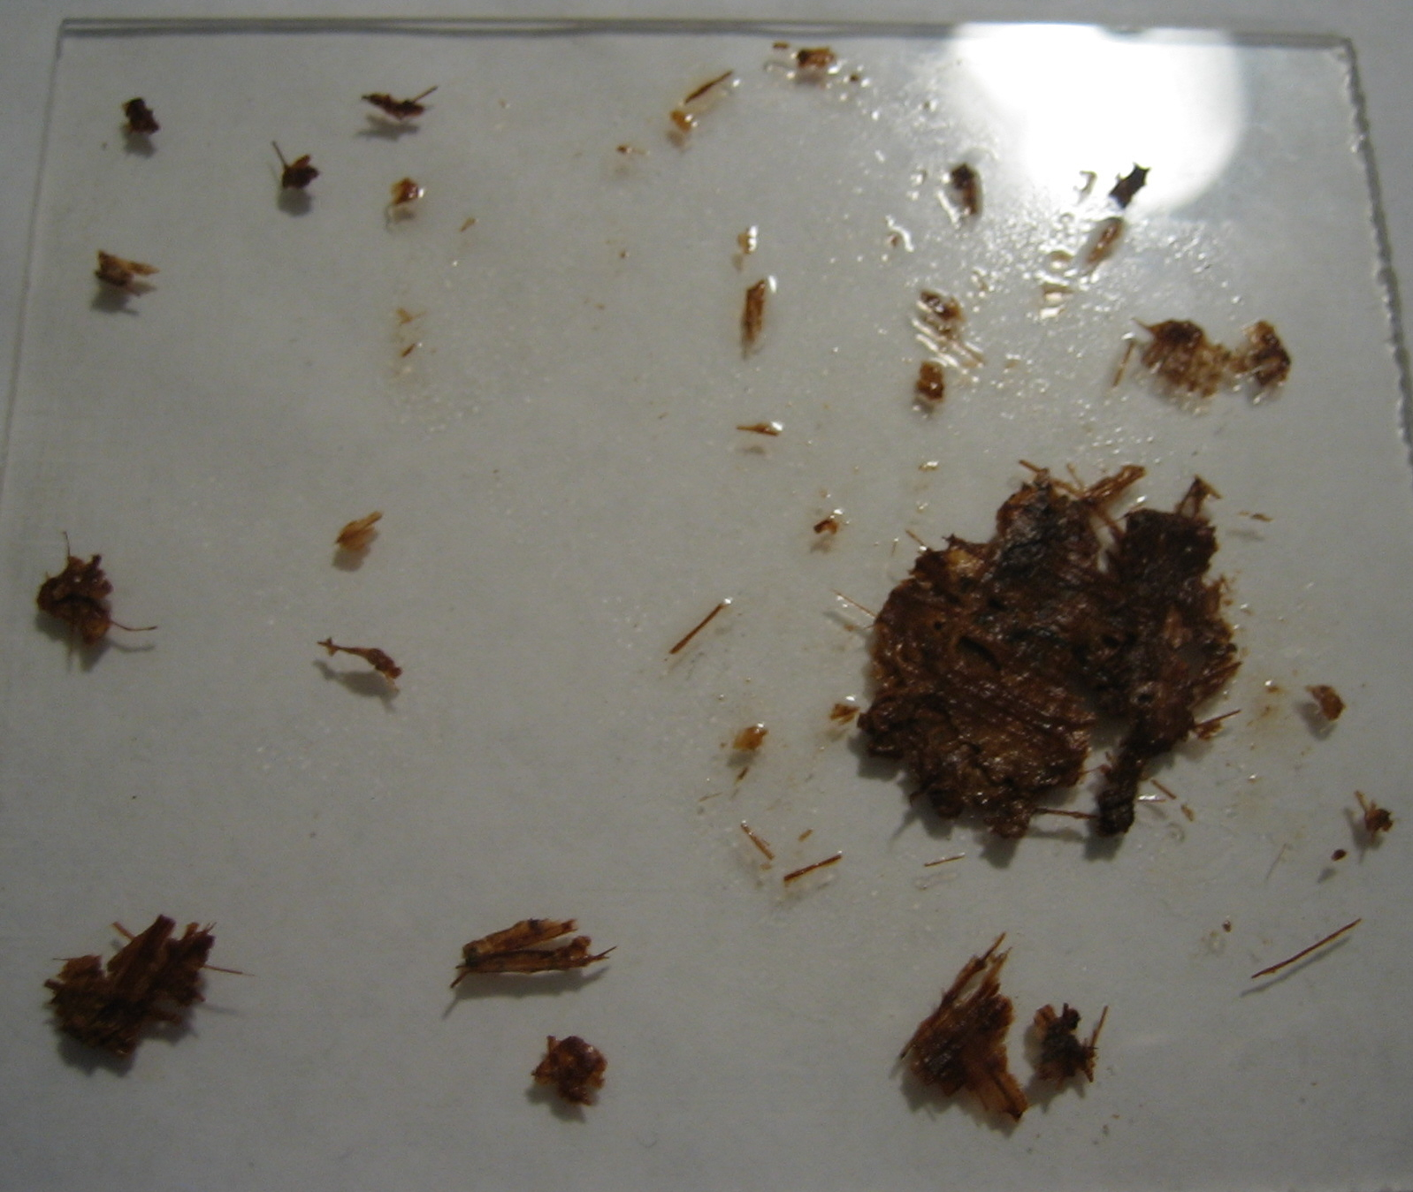

As I continued to attempt to separate the layers whose edges were visible and curled due to the alcohol soak, the papyrus continued to break apart due its the delicate condition. Although all the layers were not separated, I stopped my attempts after breaking off a large part of the papyrus. I concluded that I had separated as much as possible without completely damaging the papyrus fragment.

Final break of fragment:
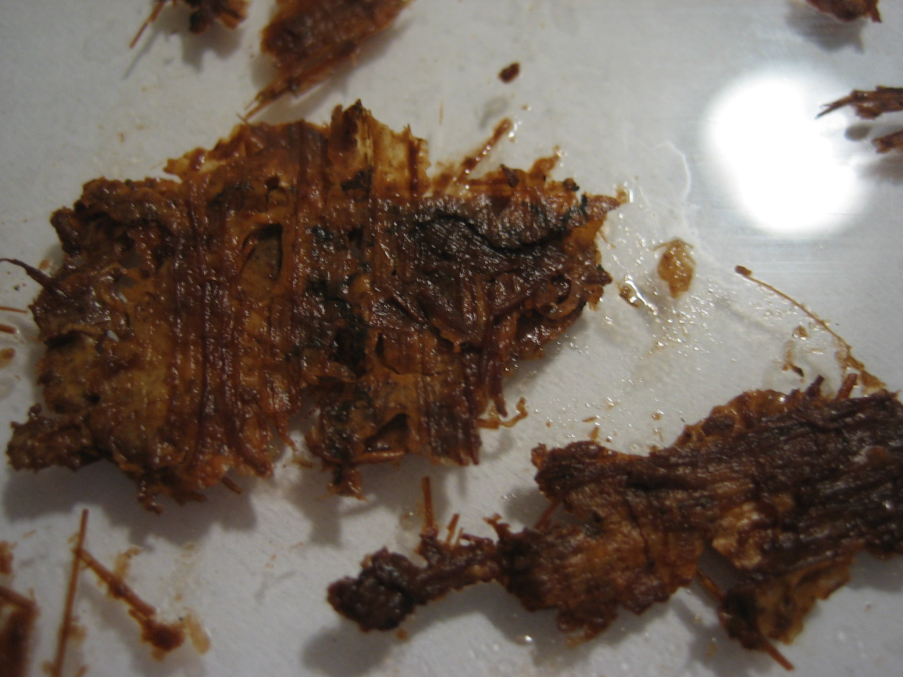
The alcohol soak darkened the color of the papyrus, and in the process, a small section on the front of the papyrus now had what appeared to be letters.

Possible writing on the fragment:
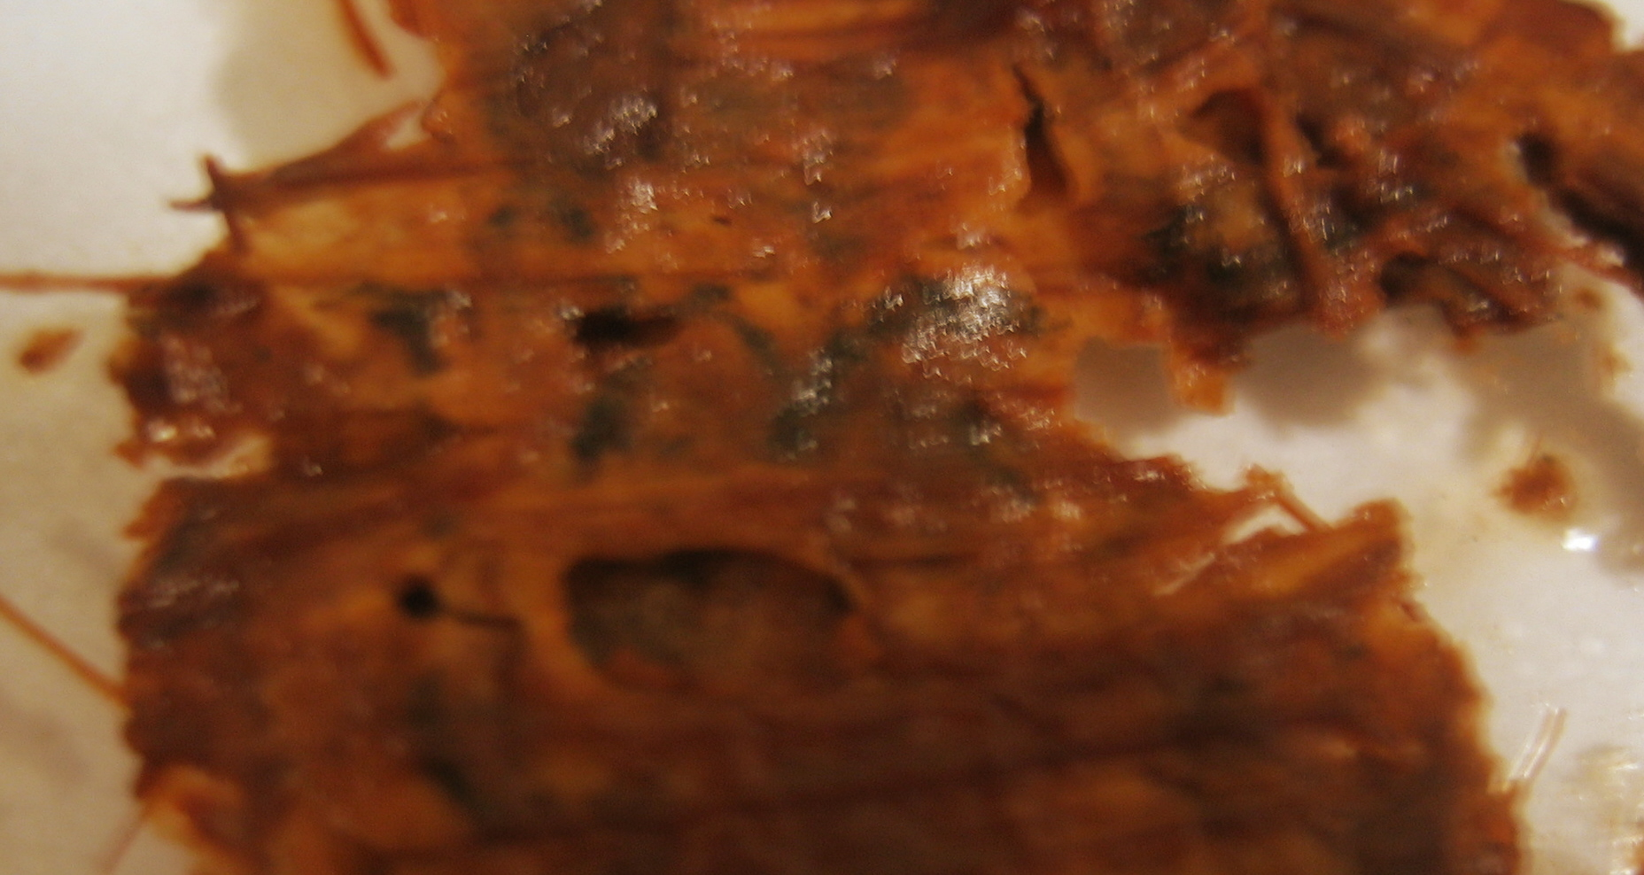

It is impossible to tell directionality from such a small portion, and it appears to only contain two letters at the most. It was difficult to tell if the writing was on the top surface of the fragment or from an underlying fragment and made visible from the alcohol soak. However, at the very beginning of treatment, the papyrus had no visible ink. Thus, it seemed logical to conclude that the alcohol soak had caused the writing on an under layer to become visible through the surface layer. Although the piece was not fully separated, I was satisfied that I had done as much as I could have with the fragment. Any additional writing would have also become visible from the alcohol soak, so there seemed to be no real reason to continue attempting to separate the fragment layers since such attempts had been so destructive. I let the fragment air dry. The discoloration of the papyrus remained, but the writing faded when the papyrus dried, supporting the fact that the ink was on an under layer rather than the surface layer. More than likely nothing further will be gained by continued attempts to separate the papyrus.

Front view of the two largest pieces of the fragment after drying:
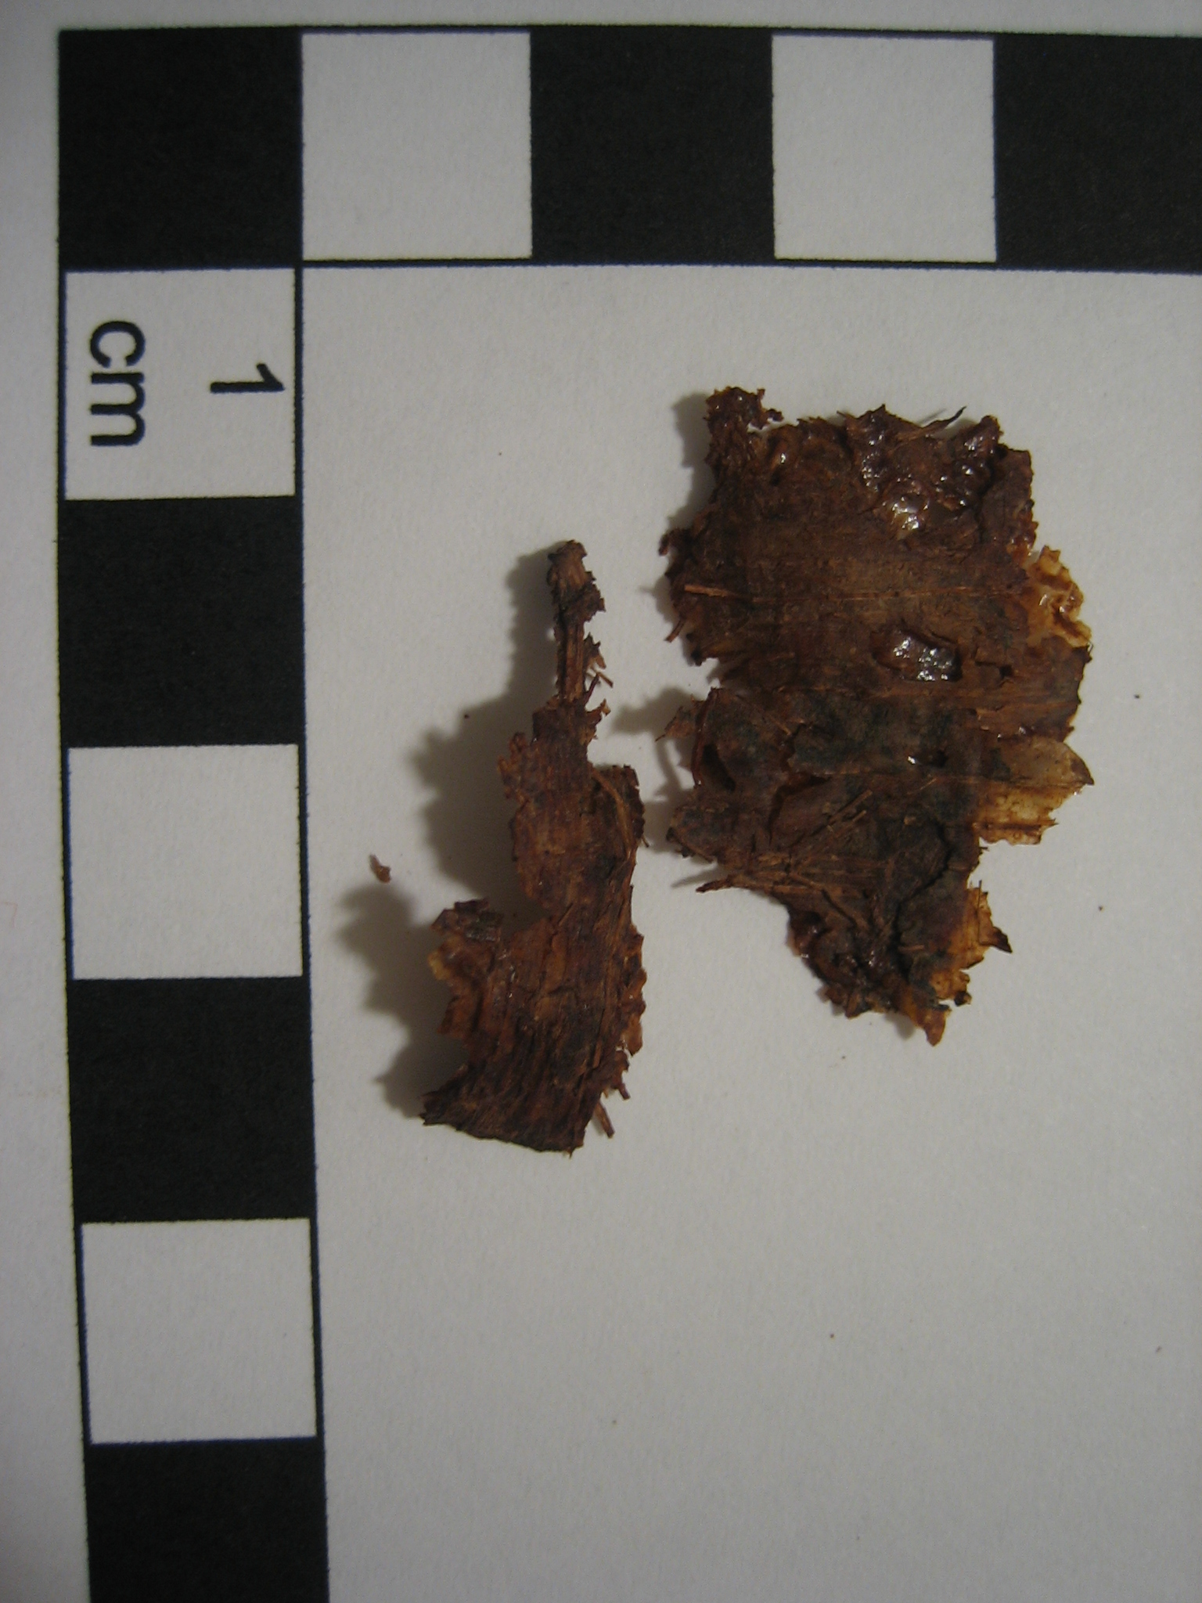

Back view of the two largest pieces of the fragment after drying:
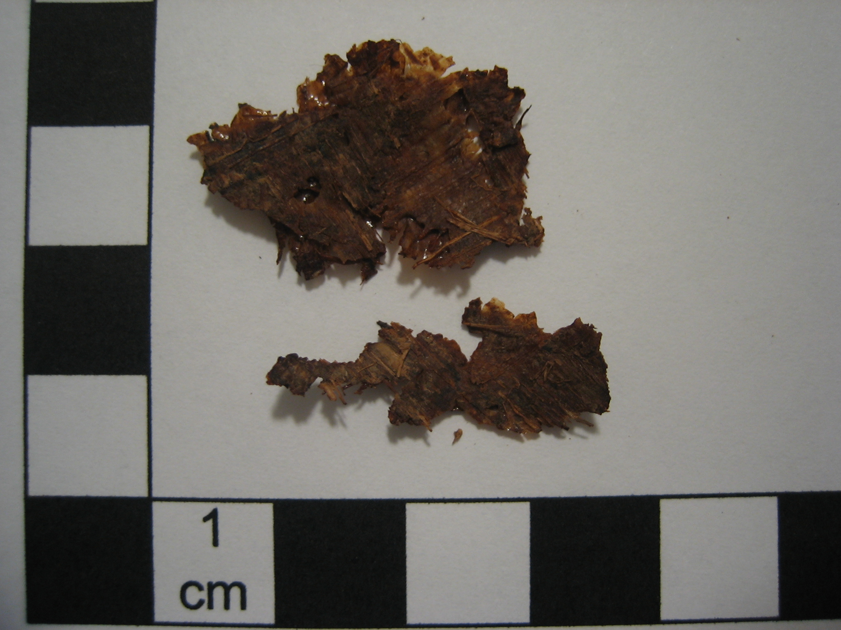
Newly exposed surface after drying:
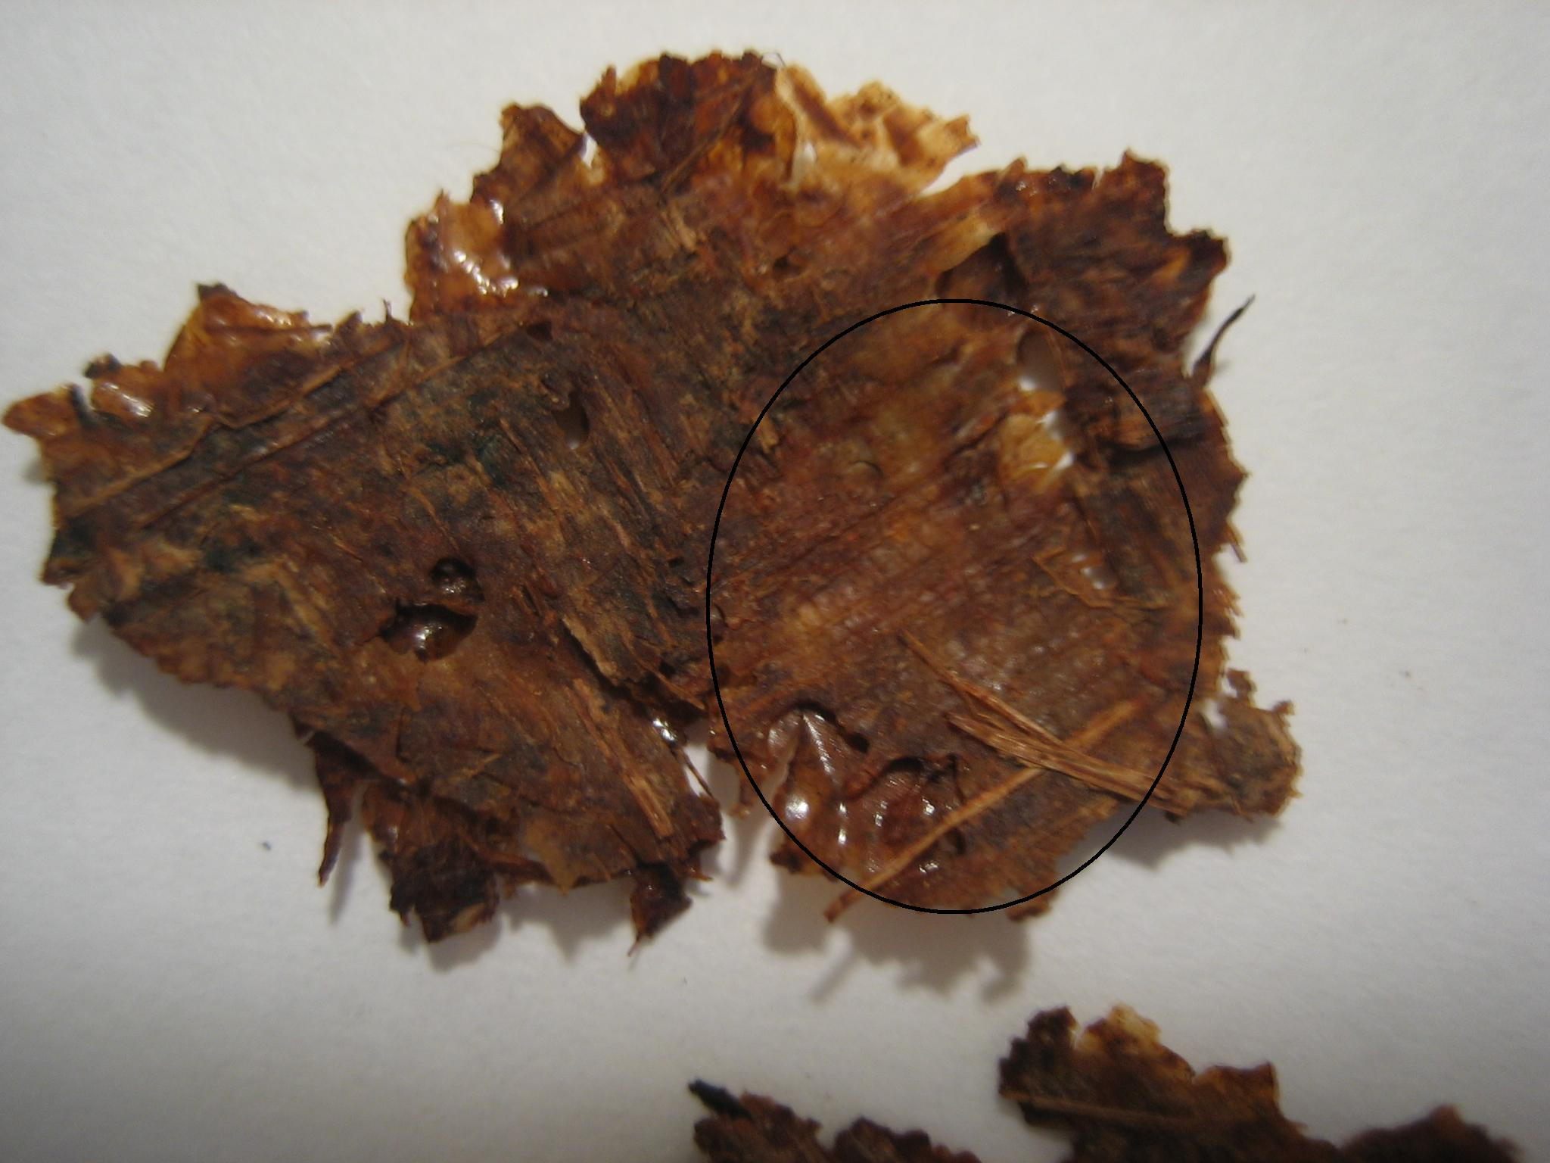

Section with lettering after drying:
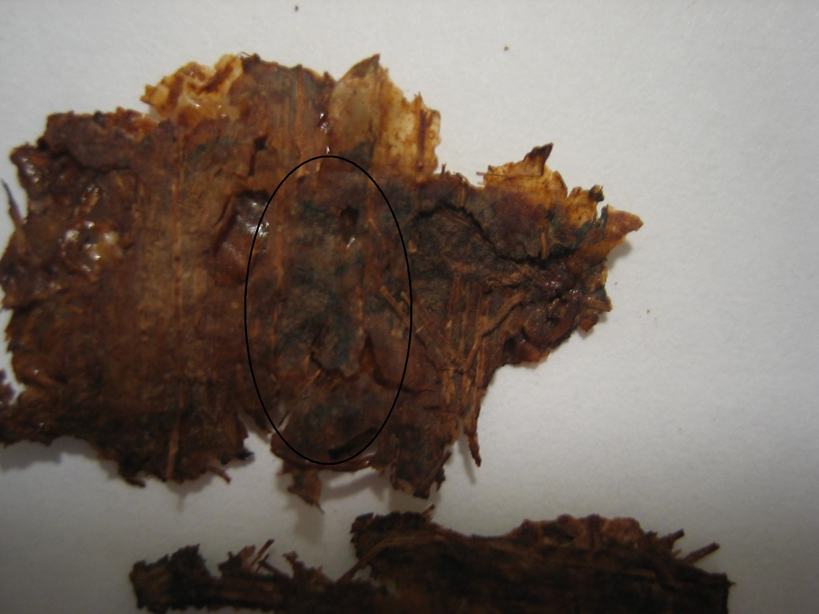
//November 2006//

